Clase nª18
…………………………………………………………………………………………………………………………………………

En ésta clase, practicaremos el verbo THINK

Look at this example:
I am tired. What time does the class end?
I think it ends at 2 o’ clock

Now answer these questions. Use think in your answer.

Example: It is cold today. Where is my hat?
I think it’s on the desk.

- I am hungry. What will we eat?

- It’s late. When will the children go to bed?

- The baby is crying. What’s the matter?

- It’s time for class. Where is Mary?

- This meat is good. What is it?

- For next class, write five sentences starting;
I think

Clase nª19
…………………………………………………………………………………………………………………………………………

Hoy practicaremos un Reading Comprehension exercise.
Luego, contestarán las preguntas.

Read please:

Linda was upset

Linda took her Spanish test two days ago. Her Spanish teacher graded the tests yesterday. This morning, Linda got her score.
There was a 59 on her test. This was a bad grade for Linda. She got sad and angry. She got upset. She began to cry. Linda cried for a few seconds; then she stopped. She dried her eyes. She looked at the test again. Only one answer was wrong.
She took the test to the teacher. The teacher looked at it and said, “I wrote the wrong score on your test, Linda. Your true score is 95.” Linda is not upset now. She is very happy.

- Answer these questions

- What did Linda do two days ago?
- What did Linda’s teacher do yesterday?
- What score did Linda get?
- Was it a good grade?
- What did Linda do?
- Did Linda cry a long time?
- Was 59 the correct score?
- How is Linda now?

- Now, translate the passage into Spanish

Clase nª20
…………………………………………………………………………………………………………………………………………

Hoy practicaremos el Simple Past Tense.

- Read the following passage:

Last Summer, my wife and I took a nice trip. We went to New York, Chicago and Los Angeles.
We visited my wife’s mother in New York.
Next, we drove to Chicago. We visited my brother there. Then, we flew to Los Angeles and visited my wife’s sister and her husband.

- Now, complete the chart
Our trip last Summer

Wife’s sister and husband.

- Now, translate the passage into Spanish

Clase nª21
…………………………………………………………………………………………………………………………………………

Hoy practicaremos un diálogo. Lean el mismo y luego contesten las preguntas.

“It’s cold in New York in the winter”
Dick: It’s nice to see you, Ben.
Ben: Dick! I didn’t think you were in town.
Dick: I came back from my trip yesterday.
Ben: How was the weather in NY?
Dick: Cold. There was a big snowstorm.
Ben: BRR! Do you think you want to live in New York?
Dick: No, I think I just want to visit.
Ben: Me, too. And only in the Summer.

- Answer:

- Where did Dick travel?
- How was the weather in NY?
- Does Dick like cold weather?
- Does Ben want to live in New York?
- Do you like cold weather or hot weather?
- Why?

- Now, translate the dialogue into Spanish

Clase nª22
…………………………………………………………………………………………………………………………………………

En ésta clase, repasaremos el verbo “to be” y las estructuras “There is/are”

- Read the following passage and then complete the chart:

I have three good friends. Sam is a cook. He works at a restaurant downtown. Betty is a doctor. She works in a New York Hospital. Ted is a pilot in the US Air Force.
My three good friends

Betty

restaurant downtown

- Can you think of your 3 good friends? Draw a chart in the way already seen.
- Read this passage and complete the chart.

There are four seasons in a year. They are spring, summer, fall and winter. Spring is March, April and May. Summer is June, July and August. Fall is September, October and November. Winter is December, January and February.
The four seasons

September, October, November.

- Draw the same chart for Argentina. Are there any differences?

Clase nª23
…………………………………………………………………………………………………………………………………………

- Read the following advertisement and then answer the questions:
Apartments on sale

Av. Scalabrini Ortiz 2083 8ºA
u$s81.500 Fte bcón 2 bño lav
Impecable! Excel Oportunidad!
t/prop ver 15 a 18h 4582-5222

Answer the questions:

- What is the address of the apartment?
- How much does it cost?
- Does it have a balcony?
- Does it have a laundry?
- Why is it an excellent opportunity?
- At what time can you see it?
- What is the owner’s telephone number?

- Imagine you are planning your holidays. Read this ad and then answer the questions:
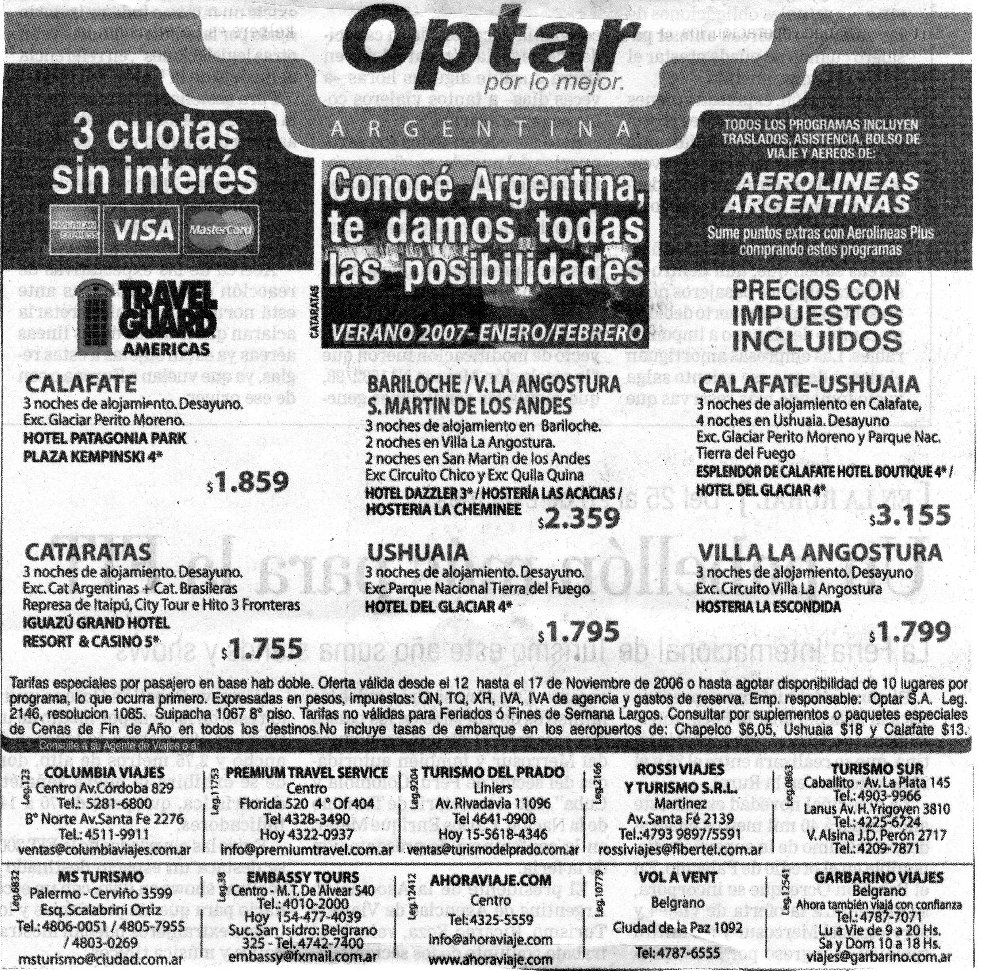

- What is the name of the travel agency?
- How much does Calafate cost?
- What does it include?
- Is Ushuaia cheaper than Calafate? How much does it cost?
- Which is the most expensive trip?
- Which is the cheapest?
- What is the name of the hotel at Villa La Angostura?
- In your opinion, which is the most interesting trip?
- How many travel agencies can you consult?
- Is there a travel agency near your home?
- Which one?

Clase nª24
…………………………………………………………………………………………………………………………………………

- Ask and answer questions like the examples.

Examples:
- What/eat?
What would you like to eat?
I’d like to eat some soup.
- Where/live
Where would you like to live?
I would like to live in Hawaii.

Now, go on
- When/leave
- Where/go
- What/watch
- How many tickets
- When/travel to California
- Where/ eat lunch
- What/play
- How/go
- What/ for breakfast
- How many pieces of toast

- Now ask and answer questions:

Examples: soup → Would you like some soup?
Yes, I would like some soup

Sugar | → | __________________________________________________?
Hamburgers | → | __________________________________________________?
Biscuits | → | __________________________________________________?
Chocolate | → | __________________________________________________?
Wine | → | __________________________________________________?
Coke | → | __________________________________________________?
Lemonade | → | __________________________________________________?
Champagne | → | __________________________________________________?
A sandwich | → | __________________________________________________?
A sweet | → | __________________________________________________?

Clase nª25
…………………………………………………………………………………………………………………………………………

- Read the following dialogues and then answer the questions.

“At the Restaurant”
Waiter: Would you like to order now?
John: Yes, I will have the fish and a salad.
Waiter What would you like to drink?
John: I’ll have a glass of tea.
Waiter: Would you like anything else?
John: I’ll order dessert later.
Waiter: All right, sir.

LATER

Waiter: Would you like to order some dessert now?
John: Yes, I’ll have a dish of vanilla ice-cream.
Waiter: Do you want anything to drink?
John: Yes, please, bring me some coffee too.
Waiter: Anything else?
John: No. Just bring me the check, please.

- Answer:

- What will John have?
- Anything else?
- When will he order dessert?
- What will he have for dessert?
- Will he take some tea?

- Now, translate the dialogue into Spanish.

Clase nª26
…………………………………………………………………………………………………………………………………………

- Read the following paragraph. Then answer the questions. Finally, translate it into Spanish.
Mr. and Mrs. White returned from their vacation two days ago. They took their vacation in the mountains this year. Mrs. White didn’t want to go to the ocean. They went to Lake Sunshine. They heard a lot of nice things about it. Many people like it. The water is clear and cold, and there are tall, green trees near it.
The, they went to San Fransisco. They wanted to go sightseeing there. Mr. White took many pictures. He likes San Francisco very much.

- Answer
- When did the Whites return from their vacation?
- Where did they go?
- Why did they go there?
- Can you describe the landscape?
- Where did they go afterwards?
- What did Mr. White take?

- Now translate the paragraph

Clase nª26
…………………………………………………………………………………………………………………………………………

Vocabulary Practice

Use your dictionaries.
On the left, you will read some professions.
On the right, you will read the objects they use.
Match the professions with their corresponding objects.

Lawyer | Water/shovel/scissors, etc
Doctor | Taxi
Dentist | Computer/books/building books/mathematics books, etc
Teacher | Plane/compass/radio/instruments, etc
Gardener | Codes/ books
Mason | Books/blackboard/chalk
Architect | Plans/drawings/computers/pencils/ charts, etc
Engineer | Aspirins/medicines/syrups, etc
Pilot | Trays/drinks/food/pillows, etc
Air – hostess | Different articles ON SALE
Shop assistant | Drill/paste/toothbrush, etc
Pharmacist | Bricks/tools/ladders, etc
Vet | Medication in general /cotton/alcohol /aspirins/combs/toothbrush, etc
Actor | Canvas/paint/brushes
Painter | Computer/pen/paper
Writer | Books on animals/medication/cages, etc
Taxi driver | Mask/costumes
Military man | Uniforms/arms/guns/maps, etc.

